**Online Food Order**

CourseProjectReportinpartialfulfillmentofthedegree

# BachelorofTechnology

in

# ComputerScience&Engineering

## By

**2203A51026 S.Harshith**

**2203A51033** **K.Vaishanavi**

**2103A51065** **P.Sreeja Reddy**

**UndertheGuidanceof**

# Dr.N.Venkatesh

# Assistant Professor, Department of CSE.

**Submittedto**



## School of Computer Science and Artificial Intelligence

## SRUNIVERSITY,ANANTHASAGAR,WARANGAL





**School of Computer Science and**

**Artificial Intelligence**

**CERTIFICATE**

ThisistocertifythattheProjectReportentitled“Crop Suggesting from Soil”isarecordofBonafide workcarriedoutbyN. Siri Chandana,T.sathvika,Y.Sushma**,** bearingRollNo(s)**2103A51026, 2103A51033, 2103A51065** duringthe academic year 2022-2023 in partial fulfillment of the award of the degree of ***Bachelorof Technology*** in **Computer Science Engineering**by the SR UNIVERSITY, WARANGAL.

# Supervisor HeadoftheDepartment

Dr.N.Venkatesh Dr. M. Sheshikala

Asst. Professor, Assoc. Prof .& HOD (CSE)

SR University SR University

**ACKNOWLEDGEMENT**

We express our thanks to course coordinator Dr.N.Venkatesh, Asst. prof. for guiding us from the beginning through the end of the course project. We express our gratitude to head of the department CS&AI, Dr. M. Sheshikala, Associate Professor for encouragement, support and insightful suggestions. We truly value their consistent feedback on our progress, which was always constructive and encouraging and ultimately drove us to the right direction.

We wish to take this opportunity to express our sincere gratitude and deep sense of respect to our beloved Dean, School of Computer Science and Artificial Intelligence, Dr C. V. Guru Rao, for his continuous support and guidance to complete this project in the institute.

Finally, we express our thank to all teaching and non-teaching staff of the department for their suggestions and timely support.

# ABSTRACT

The advent of online food ordering has revolutionized the way consumers interact with the food industry. This paper explores the multifaceted benefits and challenges associated with online food ordering, examining its impact on both customers and businesses. Through a comprehensive literature review, the study highlights the significant growth in the online food ordering market, with projections indicating a substantial increase in market value by 2027. The convenience for customers, the increase in sales and brand awareness for businesses, and the potential for customer retention through personalized experiences are key factors driving this growth.

The paper outlines a research design framework for investigating online food ordering, detailing steps from defining research questions to reporting results. The methodology section describes the application of various machine learning algorithms, including logistic regression, K-Nearest Neighbor, Naive Bayes, Decision Tree, and Support Vector Machine, to analyze datasets and predict outcomes in the context of online food ordering.

The study's findings underscore the importance of online food ordering platforms in providing convenience to customers and valuable insights to businesses. The integration of advanced technologies, such as social media and predictive algorithms, is anticipated to further enhance the user experience and business opportunities in the future. This research contributes to the understanding of the online food ordering ecosystem and offers guidance for future studies in this rapidly evolving field.

# TableofContents

|  |  |  |
| --- | --- | --- |
| **S.NO** | **Content** | **PageNo** |
| 1 | Introduction | 1 |
| 2 | LiteratureReview | 2 |
| 3 | Design | 3 |
| 4 | Methodology | 4 |
| 5 | DataPre-processing | 6 |
| 6 | Results | 9 |
| 7 | Conclusion | 12 |
| 8 | Future scope | 12 |
| 9 | References | 12 |

**1.INTRODUCTION:**

# Online food ordering is a convenient and efficient way for customers to purchase meals from restaurants. It allows customers to browse and order from a variety of restaurants through a website or app, without having to physically go to the restaurant. This can save customers time and energy, as they do not have to wait in line or deal with crowds.

# One of the main advantages of online food ordering for businesses is the ability to reach a wider audience and increase sales. By having an online presence, restaurants can attract new customers and increase their brand awareness. Additionally, online ordering platforms provide valuable data and insights about customer preferences and ordering habits, which can be used to improve menu offerings and marketing strategies.

# Another advantage of online food ordering is the opportunity for customer retention through personalized ordering experiences. Many online ordering platforms allow customers to create profiles and save their favorite orders, making it easy for them to reorder their favorite meals. Additionally, some platforms offer rewards and loyalty programs, which can incentivize customers to return to a restaurant and make repeat purchases.

# The future of online food ordering is likely to involve further advancements in technology, such as the integration of social media platforms and the use of algorithms to predict customer orders. This can provide even greater convenience and personalization for customers, and more opportunities for businesses to reach new customers and increase sales.

# In conclusion, online food ordering is a convenient and efficient way for customers to purchase meals from restaurants. It benefits both customers and businesses by providing convenience, increasing sales and brand awareness, and offering opportunities for personalization and customer retention. With the continued advancement of technology, the future of online food ordering is likely to be characterized by even greater convenience and personalization.

# 2.LITERATUREREVIEW

Online food ordering has become a major part of the food industry in recent years. According to a report by ResearchAndMarkets, the global online food ordering market is expected to reach a value of $164.5 billion by 2027, growing at a CAGR of 12.1% from 2022 to 2027 (ResearchAndMarkets, 2022). This growth is driven by the convenience and efficiency that online food ordering offers to customers, as well as the opportunities it provides for businesses to increase sales and brand awareness.

One of the main advantages of online food ordering for customers is the convenience it offers. A study by the National Restaurant Association found that 54% of consumers prefer to order food online rather than in person (National Restaurant Association, 2021). This is due to the fact that online ordering allows customers to browse and order from a variety of restaurants from the comfort of their own home or on-the-go, saving time and energy.

Online food ordering systems also benefit businesses by increasing sales and brand awareness. A study by GrubHub, a leading online food ordering platform, found that restaurants using their platform saw an average increase in sales of 30% (GrubHub, 2021). Additionally, online ordering platforms provide businesses with valuable data and insights about customer preferences and ordering habits, which can be used to improve menu offerings and marketing strategies.

Another advantage of online food ordering is the opportunity for customer retention through personalized ordering experiences. According to a report by Deloitte, 68% of customers say that they would be more likely to return to a restaurant that offers a personalized experience (Deloitte, 2021). Online ordering platforms allow customers to create profiles and save their favorite orders, making it easy for them to reorder their favorite meals. Additionally, some platforms offer rewards and loyalty programs, which can incentivize customers to return to a restaurant and make repeat purchases.

The future of online food ordering is likely to involve further advancements in technology, such as the integration of social media platforms and the use of algorithms to predict customer orders. This can provide even greater convenience and personalization for customers, and more opportunities for businesses to reach new customers and increase sales.

In conclusion, online food ordering is a growing market that offers convenience and efficiency to customers and opportunities for businesses to increase sales and brand awareness. The use of online ordering platforms can provide personalized ordering experiences, leading to customer retention and loyalty. The future of online food ordering is likely to involve further advancements in technology, such as the integration of social media platforms and the use of algorithms to predict customer orders.

References:

ResearchAndMarkets. (2022). Global Online Food Ordering Market Report 2022. Retrieved from <https://www.researchandmarkets.com/reports/5295478/global-online-food-ordering-market-report-2022>

National Restaurant Association. (2021). Restaurant Industry 2021.

Retrieved from <https://www.restaurant.org/research/restaurant-industry-2021>

GrubHub. (2021). The State of the Restaurant Industry 2021. Retrieved from <https://www.grubhub.com/blog/the-state-of-the-restaurant-industry-2021>

Deloitte. (2021). The Restaurant of the Future: Creating a Personalized Experience. Retrieved from

https://www2.deloitte.com/us/en/pages/consumer-business/articles/restaurant-of-the-future-creating-a-personalized-experience.html

**3.DESIGN:**

Designing a research study on online food ordering involves several steps, including:

* **Defining the research question and objectives:** Clearly define the research question and objectives, and identify the specific information that you want to gather about online food ordering.
* **Selecting a research design:** Choose a research design that is appropriate for the research question and objectives. The most commonly used research design in online food ordering studies is the survey-based design.
* **Choosing a sample:** Determine the appropriate sample size and characteristics, and consider factors such as demographics, online ordering behavior, and restaurant preferences.
* **Selecting a data collection method:** Choose a data collection method that is appropriate for the research question and objectives. Common methods include online surveys, interviews, and focus groups.
* **Designing the data collection instrument:** Create a data collection instrument, such as a survey, that is valid and reliable. Ensure that the instrument is easy to use and understand, and that it includes questions that are relevant to the research question and objectives.
* **Pre-testing the data collection instrument:** Pre-test the data collection instrument with a small sample to ensure that it is functioning properly and that the data being collected is accurate.
* **Collecting data:** Administer the data collection instrument to the sample, and ensure that the data is collected in a consistent and unbiased manner.
* **Analyzing data:** Analyze the data using statistical methods, such as regression analysis, and interpret the results in the context of the research question and objectives.
* **Reporting the results:** Present the results in a clear and concise manner, and include relevant details such as the research question, objectives, sample, data collection method, and statistical analysis

# 4. METHODOLOGY:

AfterDatapre-processing and data visualization the next step is to apply the models on the dataset. Our dataset comes under supervised learning as it contains the labeled data (target variables, feature variables). First the dataset is splitted into training set and testing set. Then the model is trained on training set and then tested on testing set.

**4.1logistic regression algorithm:**

Logistic regression is a machine learning algorithm which comes under supervised learning. It is a parametric method, where an equation is formed to solve. The equation returns continues values. These continues values should to converted to categorical values.so, we use a activation function called “sigmoid”.by using log error function we calculate the error.

* from sklearn.linear_model import LogisticRegression
* lr=LogisticRegression()
* mm=lr.fit(x_resem_train,y_resem_train)

**4.2K-Nearest Neighbor algorithm:**

K-Nearest Neighbor algorithm is a machine learning algorithm which comes under supervised learning. This is used for both classification and regression. This algorithm is non parametric. This is also called as lazy learning algorithm. This algorithm works by first selecting the k value which is an integer value and less than the number of rows. When a new data point is given, KNN finds the nearest neighbors to that data point based on the distance using various methods like Euclidean distance or Manhattan distance. And assigns the data point to that class.

* from sklearn.neighbors import KNeighborsClassifier
* classifier=KNeighborsClassifier(n_neighbors=5,metric='minkowski',p=2)
* classifier.fit(x_resem_train,y_resem_train

**4.3Naive Bayes algorithm:**

# Naive Bayes algorithm is a machine learning algorithm which comes under supervised learning. This is used for both classification and regression.This algorithm is non parametric. This algorithm works based on the bayes theorem. Naive Bayes algorithm is a probabilistic classifier. It predicts the probability of an object. And also it does not require much training data.

* from sklearn.naive_bayes import GaussianNB
* gnb=GaussianNB()
* gnb.fit(x_resem_train,y_resem_train)

# 4.4Desicion Tree algorithm:

# Decision tree algorithm is a machine learning algorithm which comes under supervised learning. This is used for both classification and regression problems. This algorithm is also known as ID3 algorithm. This algorithm is non parametric method. It forms a tree from the given dataset. It has two nodes decision nodes and leaf nodes. Decision nodes are used for taking decisions and leaf nodes are the output of that decisions. The attribute selection happens by entropy and information Gini.

* from sklearn.tree import DecisionTreeClassifier
* classifier=DecisionTreeClassifier(criterion='entropy',random_state=0)
* mm=classifier.fit(x_resem_train,y_resem_train)

# 4. 5support vector machine algorithm:

# Support vector machine algorithm is a machine learning algorithm which comes under supervised learning. This is used for both classification and regression problems. SVM works by constructing a hyperplane or a line that separates the different classes of data points. SVM has support vectors. The distance between positive hyperplane and negative hyperplane is called margin.

* from sklearn.svm import SVC
* svm_model=SVC(kernel='linear')
* svm_model.fit(x_resem_train,y_resem_train)

# 5.DATASETPREPROCESSING:

# DATASET DESCRIPTION

# Attributes:

# Age

# Gender

# Marital status

# Occupation

# Monthly Income

# Educational Qualification

# Family size

# Latitude

# Longitude

# Pin code

# Output

# Feedback

**Dataset**

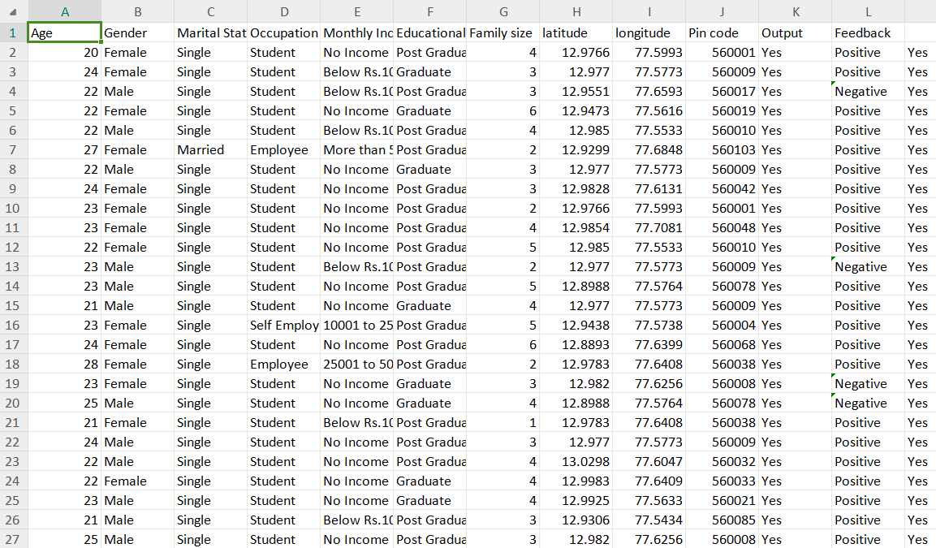

# 6. RESULTS:

**CODE**

**Dataset:**

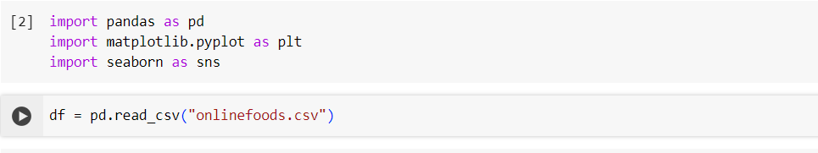

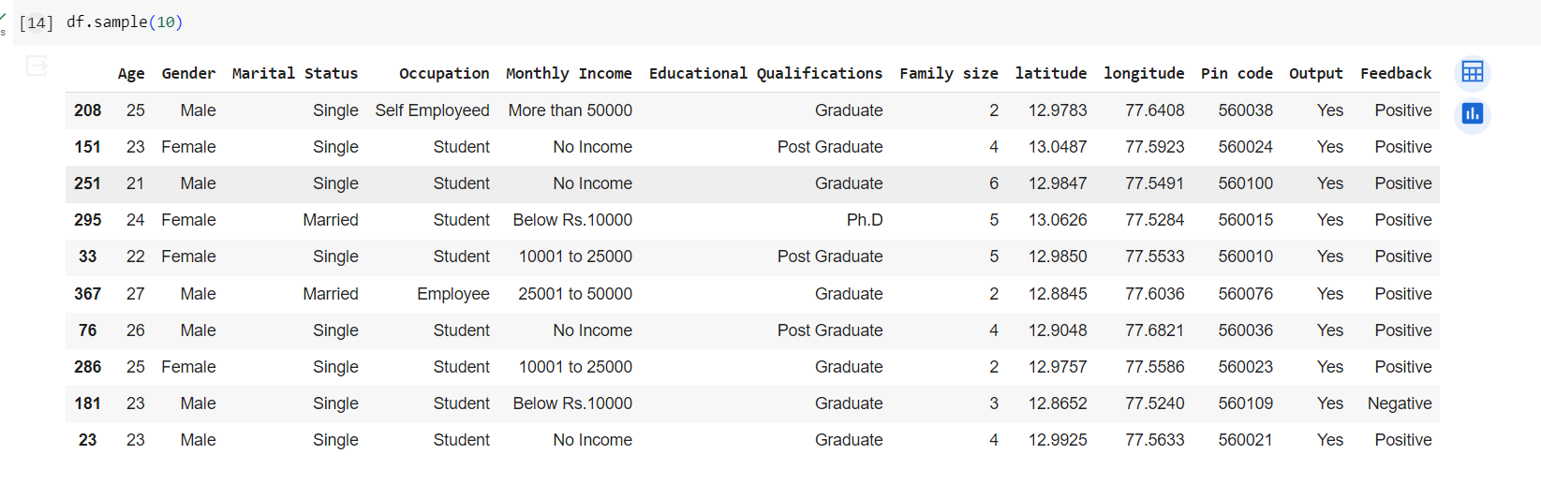

**Histplot:**

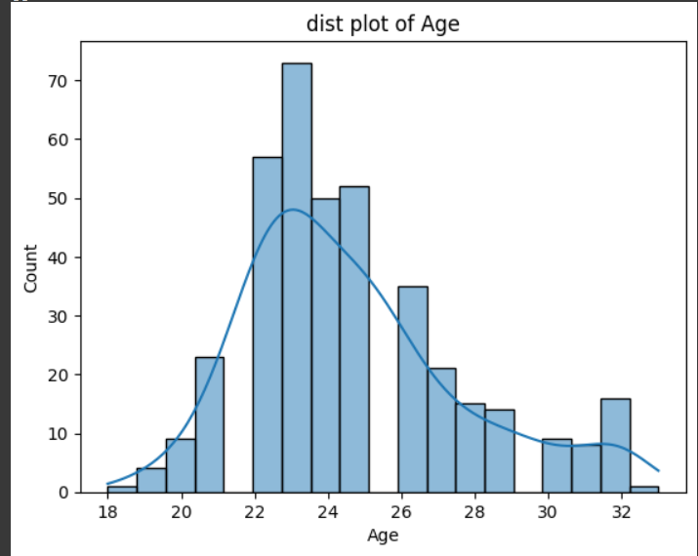

**Quantiles:**

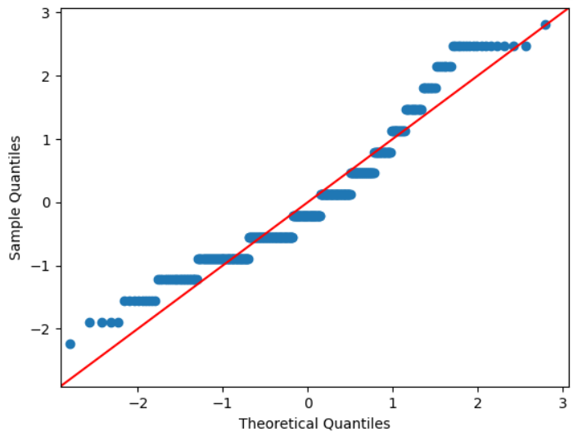

**Boxplot:**

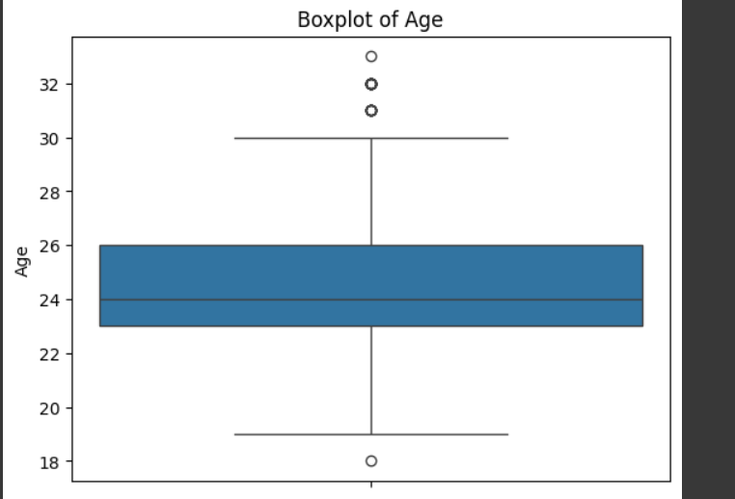

**Boxplot of age with other column:**

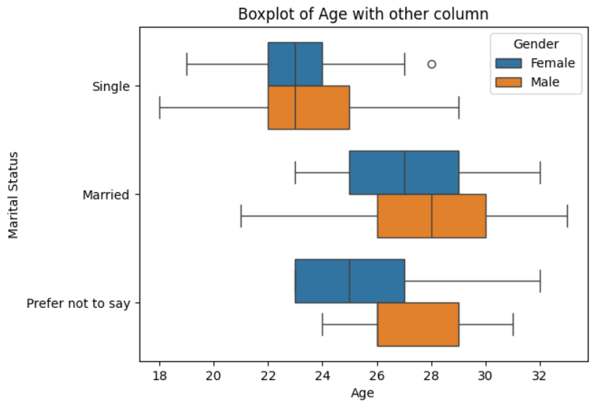

**Countplot:**

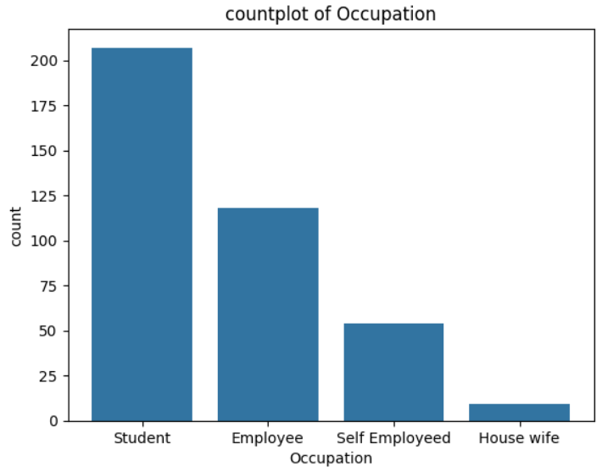

# 7. CONCLUSION:

Onlinefood ordering is a growing market that offers convenience and efficiency to customers and opportunities for businesses to increase sales and brand awareness. The use of online ordering platforms can provide personalized ordering experiences, leading to customer retention and loyalty. The future of online food ordering is likely to involve further advancements in technology, such as the integration of social media platforms and the use of algorithms to predict customer orders.

**8. FUTURE SCOPE :**

# There are several areas for future research in the field of online food ordering. These include the use of artificial intelligence and machine learning to improve the personalization and efficiency of online food ordering systems, the integration of social media platforms to enhance the customer experience, and the use of data analytics to gain insights into customer behavior and preferences.

# 9. REFERENCES:

1. ResearchAndMarkets. (2022). Global Online Food Ordering Market Report 2022. Retrieved from https://www.researchandmarkets.com/reports/5295478/global-online-food-ordering-market-report-2022
2. National Restaurant Association. (2021). Restaurant Industry 2021. Retrieved from https://www.restaurant.org/research/restaurant-industry-2021

[3] GrubHub. (2021). The State of the Restaurant Industry 2021. Retrieved from https://www.grubhub.com/blog/the-state-of-the-restaurant-industry-2021

[4] Deloitte. (2021). The Restaurant of the Future: Creating a Personalized Experience. Retrieved from https://www2.deloitte.com/us/en/pages/consumer-business/articles/restaurant-of-the-future-creating-a-personalized-experience.html